Found Quasars around PHz 125046 (RA-156.23729 dec-18.823875)

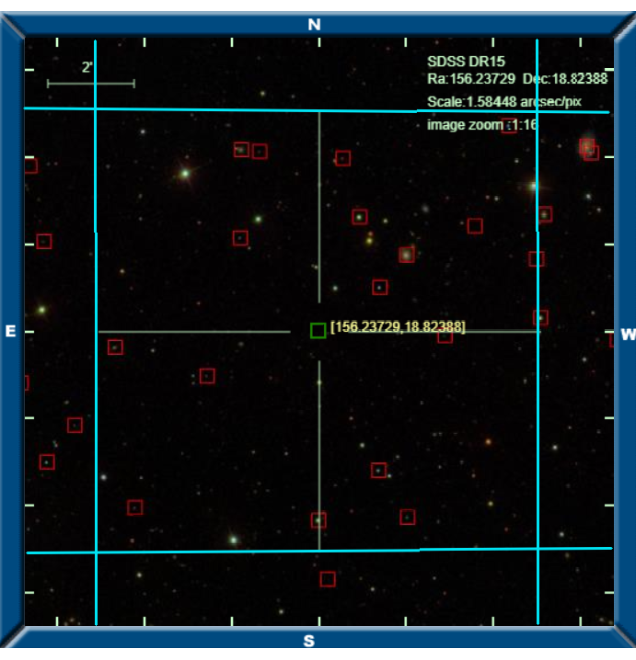

Image, blue radius around PHz 125046 is 5” from skysurver.sdss.org

|  |  |  |  |  |  |  |
| --- | --- | --- | --- | --- | --- | --- |
| **Quasar Name** | **Classification on SDSS** | **Redshift** | **RA** | **dec** | **Spectrum** | **Distance (arcmin)** |
| n/a | n/a | n/a | n/a | n/a | n/a | n/a |

|  |  |  |  |  |  |  |
| --- | --- | --- | --- | --- | --- | --- |
| **Star Name** | **Classification on SDSS** | **Redshift** | **RA** | **dec** | **Spectrum** | **Distance (arcmin)** |
|  |  |  |  |  | [spec](http://skyserver.sdss.org/dr15/en/get/SpecById.ashx?id=6625018903914323968) |  |
|  |  |  |  |  | [spec](http://skyserver.sdss.org/dr15/en/get/SpecById.ashx?id=3229192882808186880) |  |
|  |  |  |  |  | [spec](http://skyserver.sdss.org/dr15/en/get/SpecById.ashx?id=2674072815140890624) |  |
|  |  |  |  |  | [spec](http://skyserver.sdss.org/dr15/en/get/SpecById.ashx?id=3212305758410532864) |  |
|  |  |  |  |  | [spec](http://skyserver.sdss.org/dr15/en/get/SpecById.ashx?id=8392644935845650432) |  |
|  |  |  |  |  | [spec](http://skyserver.sdss.org/dr15/en/get/SpecById.ashx?id=6624860574239924224) |  |
|  |  |  |  |  | [spec](http://skyserver.sdss.org/dr15/en/get/SpecById.ashx?id=3212303284509370368) |  |
|  |  |  |  |  | [spec](http://skyserver.sdss.org/dr15/en/get/SpecById.ashx?id=8392641362432860160) |  |
|  |  |  |  |  | [spec](http://skyserver.sdss.org/dr15/en/get/SpecById.ashx?id=3229196181343070208) |  |
|  |  |  |  |  | [spec](http://skyserver.sdss.org/dr15/en/get/SpecById.ashx?id=8392643836334022656) |  |
|  |  |  |  |  | [spec](http://skyserver.sdss.org/dr15/en/get/SpecById.ashx?id=3229195631587256320) |  |

|  |  |  |  |  |  |  |
| --- | --- | --- | --- | --- | --- | --- |
| **Qalaxy Name** | **Classification on SDSS** | **Redshift** | **RA** | **dec** | **Spectrum** | **Distance (arcmin)** |
|  |  |  |  |  | [spec](http://skyserver.sdss.org/dr15/en/get/SpecById.ashx?id=2674068417094379520) |  |
|  |  |  |  |  | [spec](http://skyserver.sdss.org/dr15/en/get/SpecById.ashx?id=2674068691972286464) |  |
|  |  |  |  |  | [spec](http://skyserver.sdss.org/dr15/en/get/SpecById.ashx?id=2674078587576936448) |  |
|  |  |  |  |  | [spec](http://skyserver.sdss.org/dr15/en/get/SpecById.ashx?id=6624861123995738112) |  |
|  |  |  |  |  | [spec](http://skyserver.sdss.org/dr15/en/get/SpecById.ashx?id=6624849579123646464) |  |
|  |  |  |  |  | [spec](http://skyserver.sdss.org/dr15/en/get/SpecById.ashx?id=6624850128879460352) |  |